FROM PROMPT TO PROFIT
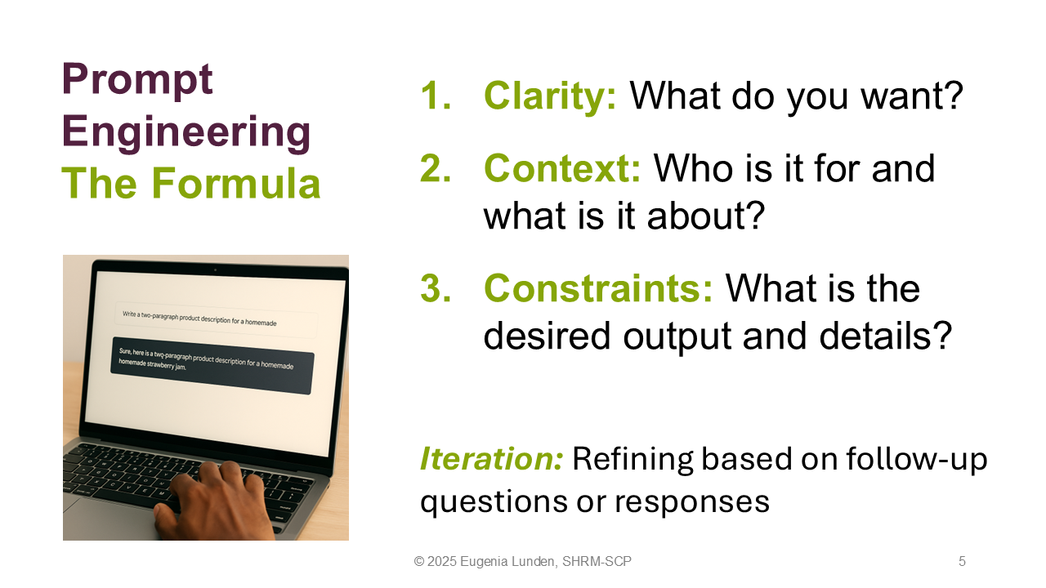
USING AI TO BOOST YOUR BUSINESS
By Eugenia Lunden, SHRM-SCP

Prompt Example #1
Act as a market research assistant. I need detailed information about the top 50 ice cream shops located in downtown San Francisco. I own an ice cream business and want to better understand my competition. Organize the results into an Excel file with columns for: Shop Name, Address, Website URL, price level, opening hours, and Yelp URL.

Prompt Example #2
Generate a realistic image of a modern ice cream shop named Below Zero. The image will be used to announce the grand opening. Show a happy customer holding a vibrant ice cream cone, with balloons in the background, a crowd enjoying treats, and a clear sunny day. The atmosphere should be fun, modern, and inviting.

